DIS-MEX-Colima-Dog Deity

The Colima believed dogs were mythic emissaries of Xolotl, the Aztec god of the dead. The dog is the animal of the dead and therefore of the Place of Shadows (Spence 2015, p. 276). In the Mayan codices, the dog is associated with the god of death, storm, and lightning (Johnson 1994: 118).

Colima dogs were patterned after a hairless variety of ancient dog known as **Xoloitzcuintli,** from the god Xolotl and *itzcuīntli*, meaning “dog” in Nahuatl (*Nahuatl Dictionary* 1997). Xolotl, with his dog, were believed to be both guides of the Sun as it traveled through the underworld every night and guides of the spirits of the dead to their resting place in the underworld.

In life **Xoloitzcuintli** dogs are a tawny gray. They have been dated to at least 700 AD/CE when the Moche made ceramic figures of them. In this Precolumbian Chancay (1200-1470) textile from the wet montane forest of the Chancay region of Peru at an altitude of 4000 feet, they were kept in the same humid greenhouse as *Sobralia rosea* orchids and this helped preserve their silky smooth skin when used as bed warmers:

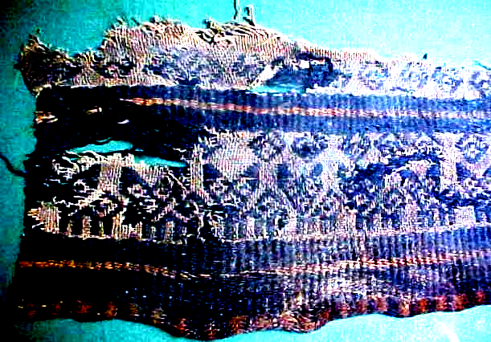

From AM,S- PERU-Chancay-1200-1470 CE-Tapestry

However, in myth they are a burnished vermilion as in this Colima terracotta ceramic, and their demeanors suggest they were considered as both a pet and a delicacy (which is implied by their often plump figures).

The color red is a clue to their Mesoamerican mythological heritage as is seen in the Codex Borgia (p. 34, below). Within the sanctuary of the Red Temple, the Sun is finally born. A warrior drills a fire on the chest of a figure lying down with the solid red disk of the solar deity in the background. Immediately to the right, the deity is enthroned in his temple. He now has canine claws, a canine maw, the wind jewel, and a distended eye that identify him as the *red* Xolotl. As the solar guide, he now carries the Sun on his back (Boone 2013).

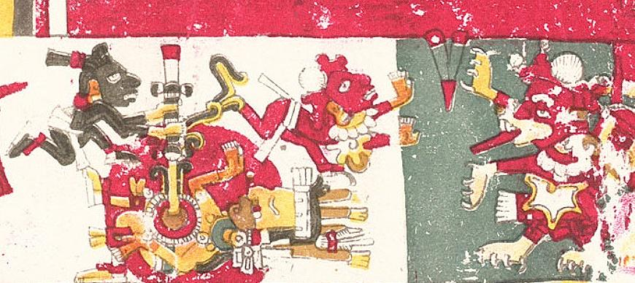

Xolotl is represented as a *red* dog, and is distinguished as the deity of air and of the four directions of the wind. His twin is Quetzalcoatl, and both are the sons of the virgin Coatlicue, the Aztec goddess who gave birth to the moon, stars, and Huitzilopochtli, the god of the Sun. Since twins in Mesoamerica were considered unnatural, one was usually sacrificed. The sacrificed twin in this case was Xolotl, portrayed as a dog, in the belief that dogs accompanied the souls of the dead to Mictlan, the underworld of Aztec mythology, while his surviving brother, Quetzalcoatl, “The Precious Surviving Twin,” dwells in the light of the Sun (Maffie 2013).

References:

Boone, Elizabeth Hill (2007). Cycles of Time and Meaning in the Mexican Books of Fate. Austin: University of Texas Press.

Coe, Sophie D. (1994) *America's first cuisines.* Austin: University of Texas Press, 1994.

Johnson, Buffie (1994). Lady of the Beasts: The Goddess and Her Sacred Animals. Inner Traditions International.

Maffie, James (2015). Aztec Philosophy: Understanding a World in Motion. University Press of Colorado

Milbrath, Susan (2013). Heaven and Earth in Ancient Mexico: Astronomy and Seasonal Cycles in the Codex Borgia. Austin: University of Texas Press.

*Nahuatl Dictionary.* (1997). Wired Humanities Project. University of Oregon.

# **Seler, Eduard (1904). Mexican and Central American Antiquities, Calendar Systems and History. Translated by Charles P. Bowditch. Mexican and Central American Antiquities, Calendar System and History (Smithsonian Institution / Bureau of Ethnology, Bulletin No. 28) Washington:** Government Printing Office.